[bdac.president@gmail.com](mailto:bdac.president@gmail.com) - Send presentation by 2:00pm

Research tool:

ChatGPT + browser:<https://www.bing.com/search?q=Bing+AI&showconv=1>

Data Notes: Las Vegas from Trip Advisor

3rd most visited city by international visitors

Hotels on the strip must compete with each other for business. Over thirty hotels. How do hotels stand out from each other? What are customers seeking from their experience? How can hotels predict hotel reviews, and what should they priorities to ensure the highest review?

Findings:

1. Priority Amenities
   1. Free Internet – International travelers would not buy unlimited data plan.
   2. Pool - Environmental concern
2. Negative Score Correlation
   1. Travelers from Asian Continent
      1. These travelers tend to be Solo travelers

Importance of User Review Analysis to a Hotel

Improve Service Quality - 1940s: Expectations have evolved over 80 years

Increase Customer Satisfaction and Retention - Our guests are less costly to keep than to find

Invest in Brand Reputation - Who are we in the world? 3rd most visited city by international visitors

Project Development - What projects will show the most return for our investments?

Problem Statement: How can hotels predict a Tripadvisor review, and what amenities should hotels prioritize in order to ensure the highest review?

Trip Advisor User Profile

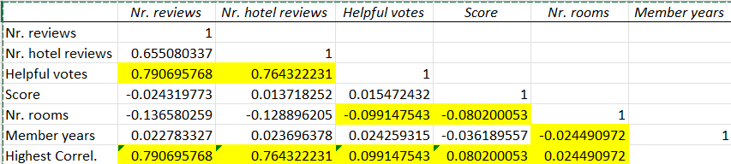

Correlation analysis in Excel between numeric-only columns shows that helpful upvotes reinforce ratings.

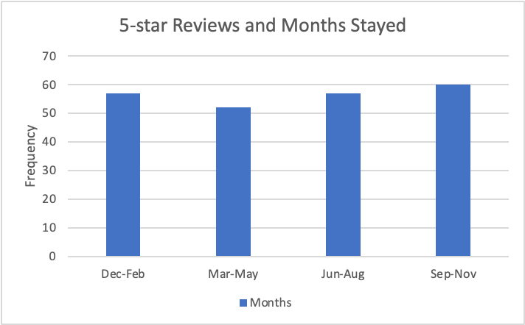

Correlation analysis between the amount of 5-star reviews and the name of the months stayed.

Talk about the presence of a pool and the amount of 5-star ratings shown when it cools off a little bit

